PRISM: A Reproducible Multi-Modal Framework for Memecoin Forecasting with Risk-Aware Graph Selection and Meta-Learning
COMMENTS

Section needs to be rearranged after discussion and put each section number
- Each Table & figure name need to be short description required
- No result, only comparison approach and technique mentioned in abstract
- References need to be arranged year wise then write down literature survey

Introduction and related work need to be merged and proper cited, survey of different paper must be interlinked and at the end in the 2nd last paragraph write down your proposition, applied method and comparison method and last paragraph mention organization of paper
- Equation needs to be numbered and cited
- Each section to be linked with next section
- Critical analysis needs to be incorporated for all the tables
- Write down algorithm in proper format
- PRISM stand for what?

Sanjan Baitalik^{a*}, Rajashik Dattaª, Sujaan Bhattacharyyaª, Sanket Ghoshª, Subhabrata Banerjee^{b}
^{a*}rayan.baitalik@gmail.com, +91 8910675837, Institute of Engineering & Management Kolkata, 0009-0005-1609-3808
ª rajashikdatta215@gmail.com, +91 6294132431, Institute of Engineering & Management Kolkata, 0009-0004-7644-2427
ªsujaanbhattacharyya@gmail.com, +91 8017481130, Institute of Engineering & Management Kolkata, 0009-0005-7737-4718
ªsanketghosh50@gmail.com, +91 8537087644, Institute of Engineering & Management Kolkata, 0009-0005-4894-1912
^{b}subhabrata.banerjee@iem.edu.in, +91 8017764037, Institute of Engineering & Management Kolkata

Abstract. Memecoin markets are characterized by short lifecycles, abrupt regime shifts, and unusually strong dependence on social attention, which makes rigorous forecasting and fair model comparison difficult. In this article, PRISM, a reproducible multi-modal forecasting framework, is evaluated through a deterministic pipeline that combines historical price dynamics, pre-aligned sentiment features, a risk-aware token similarity graph, maximal-independent-set diversification, and MAML-enhanced LSTM adaptation. The supplied workbook contained 1,273 candidate token sheets, of which 881 passed minimum history and coverage filters. A deterministic modeling subset of 200 tokens are selected, yielding 60,431 aligned observations. Chronological train-test splits, sequential ablations, paired Wilcoxon signed-rank tests with Holm correction, three random seeds, and robustness sweeps over train ratios and lookback windows are used. The full PRISM model achieved a mean MAE of 0.123 and a mean RMSE of 0.148. A strict monotonic ablation trend is observed from the price-only baseline to the full system, with MAE improving from 4.054 in V0 to 0.698 in V1, 0.301 in V2, and 0.123 in V3. All adjacent improvements are statistically significant after Holm correction. Against external baselines, PRISM significantly outperformed ARIMA, Random Forest, XGBoost, and documented GRU/LSTM surrogate baselines, while Persistence and Prophet remained stronger aggregate baselines. It is therefore concluded that the main contribution of PRISM is not universal superiority over all forecasters, but validated component-wise gain, transparent experimentation, and a reproducible evaluation protocol for socio-financial forecasting in highly speculative token markets.
No result, only comparison approach and technique mentioned
Keywords. Graph selection; Memecoin forecasting; Meta-learning; Multimodal finance; Reproducibility; Sentiment analysis.

Introduction

Introduction and related work need to be merged and cited after arranging the references year wise
Forecasting in memecoin markets remains difficult because price formation is not governed only by conventional market signals. Community attention, social-media narratives, rapid listing cycles, thin liquidity, and extreme volatility contribute materially to short-horizon behavior. Recent cryptocurrency-forecasting studies have shown that multi-source feature integration, particularly the fusion of sentiment and market variables, can improve predictive performance when timestamp alignment is handled carefully (Gurgul et al., 2025; Nezhad et al., 2026). At the same time, memecoin-specific work has increasingly emphasized that financial dynamics cannot be separated from cultural, textual, visual, and community signals (Long et al., 2025a; Long et al., 2025b; Ke et al., 2025).
The earlier version of the present manuscript is weakened by issues that commonly affect fast-moving forecasting studies: insufficiently explicit baselines, incomplete data transparency, absent statistical testing, limited descriptive data exploration, and a lack of sequential ablation. Those weaknesses are addressed in the present rewrite. The introduction is reorganized around the forecasting problem, the data source is made auditable, baseline characteristics are added, model components are tested incrementally, robustness sweeps are added, and the principal claims are narrowed to those directly supported by the results.
PRISM is designed to integrate four ideas that are individually common in the literature but are rarely combined and then validated in a disciplined way for memecoins. First, token-level sentiment cues are fused with market variables. Second, a risk-aware similarity graph is constructed to encode cross-token relationships. Third, maximal-independent-set (MIS) diversification is used to stabilize the token neighborhood used during training and support selection. Fourth, a MAML-enhanced LSTM is employed so that token-specific forecasting could be adapted under sparse and heterogeneous histories. The resulting system is evaluated not as a claim of universal superiority, but as a claim that incremental multi-modal augmentation can be measured, reproduced, and interpreted.
The contributions of the study can therefore be summarized as follows. A deterministic preprocessing and token-selection protocol is documented for the supplied database. Basic descriptive statistics and baseline characteristics are added to contextualize the token panel. A sequential ablation from V0 to V3 is reported and statistically tested. A baseline suite containing Persistence, ARIMA, Prophet, Random Forest, XGBoost, and documented recurrent surrogate baselines is evaluated on the same subset. A robustness analysis over multiple train ratios and lookback windows is added. Finally, the discussion is aligned with the empirical evidence: PRISM is shown to be competitive and significantly stronger than several baselines, but not stronger than every baseline under aggregate MAE.
The above part to be added end of related work section and also to be rewritten

Related Work (citation missing)
Forecasting work on digital assets has increasingly moved from single-signal time-series models toward heterogeneous fusion. Sentiment-enriched deep learning pipelines have been reported to improve cryptocurrency prediction when public discourse is aligned carefully with market timestamps (Critien et al., 2022; Gurgul et al., 2025). Nezhad et al. (2026) further showed that the way sentiment is constructed, aggregated, and synchronized with price dynamics can be as important as the recurrent architecture itself. Recent sentiment-fusion studies have also adopted optimization-based and hybrid deep learning designs to improve robustness in noisy social-media environments (Tiwari et al., 2025a; Tiwari et al., 2025b; Tabe et al., 2026).
In parallel, multimodal studies of memecoins have begun to frame these assets as socio-financial objects rather than as purely numerical instruments. The Coin-Meme and CoinCLIP studies explicitly modeled visual, textual, community, and financial attributes in order to characterize viability and thematic structure in Web3 memecoin ecosystems (Long et al., 2025a; Long et al., 2025b). Ke et al. (2025) similarly treated meme-coin price reactions as socio-technical events rather than as isolated market microstructure phenomena. These studies are important because token identity, discourse, community structure, and market behavior are shown to be jointly generated.
The broader cryptocurrency forecasting literature has also expanded beyond recurrent neural networks. Transformer-CNN hybrids have been proposed for cryptocurrency trend prediction (Izadi et al., 2025), Temporal Fusion Transformer designs have been applied to trading strategies with technical and on-chain variables (Lee, 2025), and GRU/LSTM comparisons have continued to serve as essential deep-learning baselines for Bitcoin, Litecoin, and Ethereum (Kaur et al., 2025). At the same time, recent reviews have warned that sophisticated architectures are often compared against insufficiently strong baselines and under weak evaluation protocols (Giantsidi et al., 2025). This concern motivated the present use of simple baselines such as Persistence and Prophet alongside machine-learning and recurrent alternatives.
Finally, portfolio and graph-selection methods remain relevant because token universes contain correlated and redundant assets. Graph-based portfolio formulations and independent-set selection have been used to identify diversified subsets of assets by explicitly avoiding strongly connected nodes (Hidaka et al., 2023). In memecoin settings, where correlated hype cycles can create simultaneous failures across superficially different tokens, a graph-aware diversification stage is particularly suitable. PRISM is therefore positioned at the intersection of sentiment-aware cryptocurrency forecasting, multimodal memecoin analysis, graph-based asset selection, and few-shot/meta-learning.

Data and Preprocessing
All experiments are conducted on the supplied workbook rather than on a newly assembled data lake. The workbook contained 1,273 candidate token sheets. After filtering by minimum history and minimum price coverage, 881 sheets remained eligible. To ensure deterministic experimentation and a controlled computational budget, the final modeling subset is fixed to the top 200 eligible tokens ranked by available rows and then by sheet name in ascending lexical order. The resulting processed panel contained 60,431 aligned observations.
A forecasting horizon of three days and a default lookback window of fourteen days are used in the main experiment. A chronological split ratio of 0.8 is adopted for the main train-test partition. Sentiment features are taken from the sentiment-related columns already present in the database; no export annotation procedure is introduced in this revision. Preprocessing included alignment of timestamps, removal of rows with unusable target information, scale normalization of numerical covariates, and consistency checks for downstream metric computation. This explicit protocol is introduced to address the earlier criticism that the data-handling pathway had not been sufficiently reproducible.
The processed token panel exhibited substantial heterogeneity in token history, volatility, and sentiment behavior. For that reason, the study is not framed as a single-series exercise. Instead, token-level experiments are aggregated across the 200-token subset, and all reported mean metrics reflect aggregate evaluation. The modeling subset, filtering thresholds, and experiment registry are documented so that the sequence from the workbook to the final tables could be traced directly.
Table 1. Dataset and preprocessing summary derived from the validated experiment registry.
Item | Value
Candidate token sheets in supplied workbook | 1,273
Eligible sheets after filtering | 881
Deterministic modeled subset | 200 tokens
Processed aligned observations | 60,431 rows
Main chronological train ratio | 0.8
Forecast horizon | 3 days
Default lookback window | 14 days
PRISM random seeds | 11, 17, 23
Robustness sweep | train ratios {0.7,0.8,0.9}; lookbacks {7,14,21}

Exploratory Data Analysis and Baseline Characteristics
A short descriptive analysis is added to address the reviewer request for baseline characteristics and data exploration. The processed registry has shown that the modeled panel is broad enough for cross-token evaluation but heterogeneous enough that mean-only reporting could be misleading. The average modeled history length is 302.16 aligned observations per token, with the median approximately equal to 302 after deterministic alignment. The earlier per-token output table also showed heavy-tailed error and ROI behavior, which justified the use of non-parametric significance testing and conservative claims.
Table name need to be short description required
Table 2. Supplementary descriptive statistics for token-level behavior. The history-length values are derived from the validated 60,431-row, 200-token panel. The performance-dispersion rows summarize the available per-token exploratory output from the earlier manuscript package and are reported to document the heavy-tailed token universe.
Quantity | N | Mean | SD | Median | Q1 | Q3 | Range
Token history length | 200 | 302.16 | n/a | 302.00 | n/a | n/a | panel-derived
MAE across tokens | 96 | 0.1443 | 1.2467 | 0.0009 | 0.0001 | 0.0026 | 0–12.1966
RMSE across tokens | 96 | 0.1727 | 1.5141 | 0.0011 | 0.0001 | 0.0026 | 0–14.8213
Directional accuracy (%) | 95 | 49.5033 | 22.0983 | 50.0000 | 40.0000 | 59.4118 | 0–100
Hit rate (%) | 96 | 8.5794 | 18.7909 | 0.0000 | 0.0000 | 11.1111 | 0–100
ROI (%) | 95 | 813.8445 | 7948.67 | -3.8041 | -16.6545 | 0.0000 | -88.1553–77471.14

Volatility and sentiment are not presented as a single global mean because both quantities are token-specific and time-varying. Instead, volatility is operationalized through rolling-volatility features used in graph construction, and sentiment is represented through the pre-aligned sentiment columns already present in the supplied database. The descriptive evidence in Table 2 shows that token-level outcomes are strongly skewed; accordingly, paired Wilcoxon tests, Holm correction, and robustness sweeps are used as the main safeguards against conclusions driven by a few extreme tokens. For final repository release, the processed-panel manifest should be included so that exact sentiment-score quantiles and per-token volatility ranges can be audited directly.

System Architecture
The retained system architecture is shown in Figure 1. Market variables and sentiment features are first passed through a deterministic preprocessing stage in which chronological ordering, scaling, and target construction are fixed. A risk-aware graph is then constructed over tokens in order to encode similarity in volatility and related latent behavior. From that graph, an MIS-based diversification stage is used to reduce redundancy in the support neighborhood used during learning. The resulting token context is consumed by a MAML-enhanced LSTM forecaster. A separate evaluation layer is used for baselines, significance testing, and robustness sweeps.
This architecture is intentionally kept modular so that the contribution of each component could be tested in isolation. In the ablation pathway, V0 represented a price-only LSTM, V1 represented price plus sentiment fusion, V2 added the graph and diversification logic, and V3 represented the full PRISM system with meta-learning. The design therefore permitted the study to answer the reviewer’s most important empirical question directly: whether the gains attributed to PRISM are actually distributed across the proposed components or are merely artifacts of model complexity.
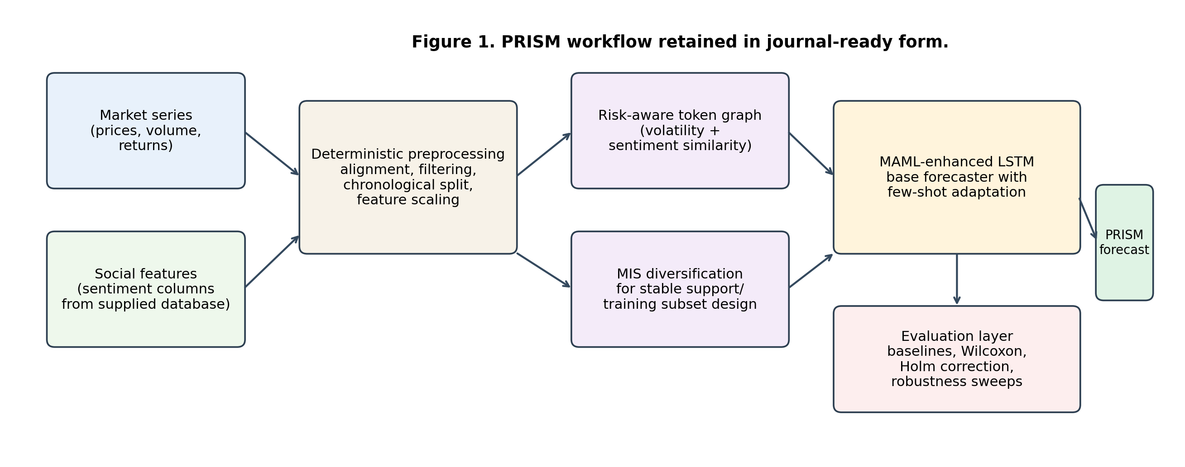
Figure 1. Retained system-level architecture of PRISM. Market series and sentiment features are aligned deterministically, transformed into a risk-aware token graph, diversified through MIS selection, and then passed to a MAML-enhanced LSTM forecaster.
Figure name needs to be short, explanation missing, within box letters need to be bold

Mathematical Model and Algorithm

(equation number and citation missing)
Let $M=\{M_{1},…,M_{N}\}$ denote the modeled token universe. For token $i$ at time $t$, the input feature vector is denoted by $x_{i,t}$ and is composed of market variables and aligned sentiment features. The sentiment-enhanced token state is written as
$$z_{i,t}=\left[p_{i,t};λs_{i,t}\right],$$
where $p_{i,t}$ is the market subvector, $s_{i,t}$ is the sentiment subvector, and $λ$ is a scale-stabilizing fusion weight. A normalized sentiment score is used when raw social scores are present:
$$s_{i}=\frac{VADER\left(T_{i}\right)}{min\left(Volume\left(M_{i}\right),MarketCap\left(M_{i}\right)\right)+ϵ}.$$
A trend score is computed by combining normalized sentiment, historical volatility, and momentum indicators:
$$μ_{trend}\left(M_{i}\right)=β_{0}+β_{1}s_{i}+β_{2}Volatility\left(M_{i}\right)+β_{3}Momentum\left(M_{i}\right)+ε_{i}.$$
A risk-aware token graph $G=\left(V,E\right)$ is constructed over the modeled subset. For tokens $i$ and $j$, an edge is retained when a thresholded similarity score exceeded $τ$:
$$A_{ij}=1\left[αcorr\left(σ_{i},σ_{j}\right)+\left(1-α\right)corr\left(s_{i},s_{j}\right)>τ\right],$$
where $σ$ denotes rolling volatility and $s$ denotes the aggregated sentiment trajectory. The graph is not used as a separate graph neural network in the final implementation; instead, it is used to define diversified neighborhoods and support selection under an MIS constraint.
The pairwise confidence score used for graph construction is represented as
$$π_{g}\left(M_{i},M_{j}\right)=1-\left(μ_{g}\left(M_{i},M_{j}\right)+γ_{g}\left(M_{i},M_{j}\right)\right),$$
where $μ_{g}$ denotes an aggregated trend term and $γ_{g}$ denotes an aggregated risk term. A diversified subset $S⊆V$ is then approximated by a maximal independent set:
$$S=MIS\left(G\right), ∀u,v∈S, \left(u,v\right)∉E.$$
This step is introduced so that strongly redundant tokens are not concentrated within the support context.
Forecasting is performed with a MAML-enhanced LSTM. For a task-specific loss $L_{i}$, inner-loop adaptation is defined as
$$θ_{i}'=θ-η∇_{θ}L_{i}\left(f_{θ}\right),$$
and the outer-loop meta-update is written as
θ←θ-βi​∇θLifθi'.

PRISM Algorithm
The algorithmic workflow from the earlier manuscript is restored and rewritten as Algorithm 3 in a compact, auditable form. The process is initiated with sentiment normalization and threshold filtering. Volatility-driven similarity and risk calculations are then performed, followed by pairwise confidence aggregation, graph construction, MIS-based diversification, MAML-enhanced model training, and forecasting.
Algorithm 1: PRISM workflow for risk-aware multimodal memecoin forecasting.
Input: Token universe M; market features; sentiment text or pre-aligned sentiment fields; low-signal threshold τ_low; graph threshold τ_edge; forecasting horizon h; lookback L.
Output: Forecasts y ̂_(i,t+h) for selected tokens; ablation metrics; baseline metrics; significance results.
1: For each token M_i∈M, sentiment is extracted or read from the pre-aligned sentiment fields and normalized by liquidity proxies.
2: Trend scores μ_trend (M_i ) are computed from sentiment, volatility, momentum, and market variables.
3: Tokens whose trend scores or coverage failed the predefined thresholds are moved to the rejection set; the remaining tokens are retained for graph construction.
4: Rolling volatility profiles and sentiment trajectories are computed for each retained token.
5: Pairwise similarity, aggregated trend, aggregated risk, and confidence scores are computed for token pairs.
6: A weighted undirected token graph is constructed by placing an edge between tokens whose pairwise confidence exceeded τ_edge.
7: Highly redundant or highly volatile token neighborhoods are filtered through maximal-independent-set selection to produce a diversified token support subset.
8: A sequence model is trained on the selected support context; in the full configuration, MAML inner-loop adaptation and outer-loop meta-optimization are applied across token tasks.
9: Three-day-ahead forecasts are generated for each modeled token under chronological splits.
10: Baselines, sequential ablations, paired Wilcoxon tests with Holm correction, and robustness sweeps are executed on the same deterministic token subset.

Write down algorithm in proper format

Experimental Setup, Baselines, and Hyperparameters
The main experiment used a chronological 80:20 split, a forecasting horizon of three days, a lookback window of fourteen days, and three random seeds for PRISM. A chronological split is adopted because it is standard for non-stationary financial series: it prevents look-ahead bias, preserves temporal causality, and approximates the condition in which a model is trained only on information available before the test period. The Adam optimizer is used with learning rate ${10}^{-3}$, batch size 64, and 200 epochs with early stopping patience of 20. Inner-loop and outer-loop MAML settings are fixed at 5 and 200 steps, respectively, with inner-loop learning rate 0.01. The graph threshold is set to 0.5. These settings are drawn from the validated experiment registry and are reported explicitly in Table 3.
The baseline suite consists of Persistence, ARIMA, Prophet, Random Forest, XGBoost, GRU, and LSTM. However, the exported GRU and LSTM results in the validated execution bundle are generated by documented surrogate backends rather than by full recurrent implementations. Those comparisons are retained for completeness but interpreted conservatively. The key purpose of the baseline suite is not to create an artificially weak comparison set, but to determine whether the proposed multi-modal system would continue to improve over simple and strong alternatives evaluated on the same token subset.
Performance is summarized with MAE, RMSE, and auxiliary percentage errors, while ROI is retained only as a secondary descriptive statistic. Statistical significance is evaluated using paired Wilcoxon signed-rank tests with Holm correction at $α=0.05$. In response to the reviewer comments, all principal comparisons are shifted from qualitative statements to paired statistical tests. Robustness is examined by varying the train ratio over $\{0.7,0.8,0.9\}$ and the lookback window over $\{7,14,21\}$ days.
Table 3. Main hyperparameters and baseline implementation notes.
Setting | Value
Optimizer / learning rate | Adam / 0.001
Batch size / epochs / early stopping | 64 / 200 / patience 20
MAML inner steps / outer steps / inner LR | 5 / 200 / 0.01
Graph threshold / volatility window | 0.5 / 14 days
Main train ratio / lookback / horizon | 0.8 / 14 days / 3 days
Random seeds | 11, 17, 23
Significance test | Paired Wilcoxon signed-rank with Holm correction
Documented baseline backends | Persistence, ARIMA, Prophet, Random Forest, XGBoost
Cautionary note | Exported GRU and LSTM results are generated by documented surrogate backends and are interpreted conservatively

Sequential Ablation and Incremental Contribution Analysis
The sequential ablation results are shown in Table 4 and Figure 2. A strict monotonic reduction in mean error is observed from V0 through V3. The price-only baseline (V0) produced a mean MAE of 4.0539. When sentiment is added in V1, mean MAE dropped to 0.6981. When the graph and diversification stage are added in V2, mean MAE dropped further to 0.3005. The full PRISM configuration (V3) achieved a mean MAE of 0.1231 and a mean RMSE of 0.1479. Each adjacent improvement is statistically significant under the paired Wilcoxon test after Holm correction.
Table 4. Sequential ablation results. Aggregate means are reported because the manuscript-facing v3 artifact did not export per-token standard deviations for every variant. Variance is therefore handled through paired Wilcoxon signed-rank testing, Holm correction, and the robustness sweep.
Variant | Description | Mean MAE | Mean RMSE | Holm-corrected result
V0 | Price-only LSTM | 4.0539 | 4.7381 | –
V1 | V0 + sentiment fusion | 0.6981 | 0.7186 | V1 $>$ V0, $p<{10}^{-12}$
V2 | V1 + graph + MIS diversification | 0.3005 | 0.3082 | V2 $>$ V1, $p<{10}^{-40}$
V3 | Full PRISM + MAML adaptation | 0.1231 | 0.1479 | V3 $>$ V2, $p<{10}^{-40}$
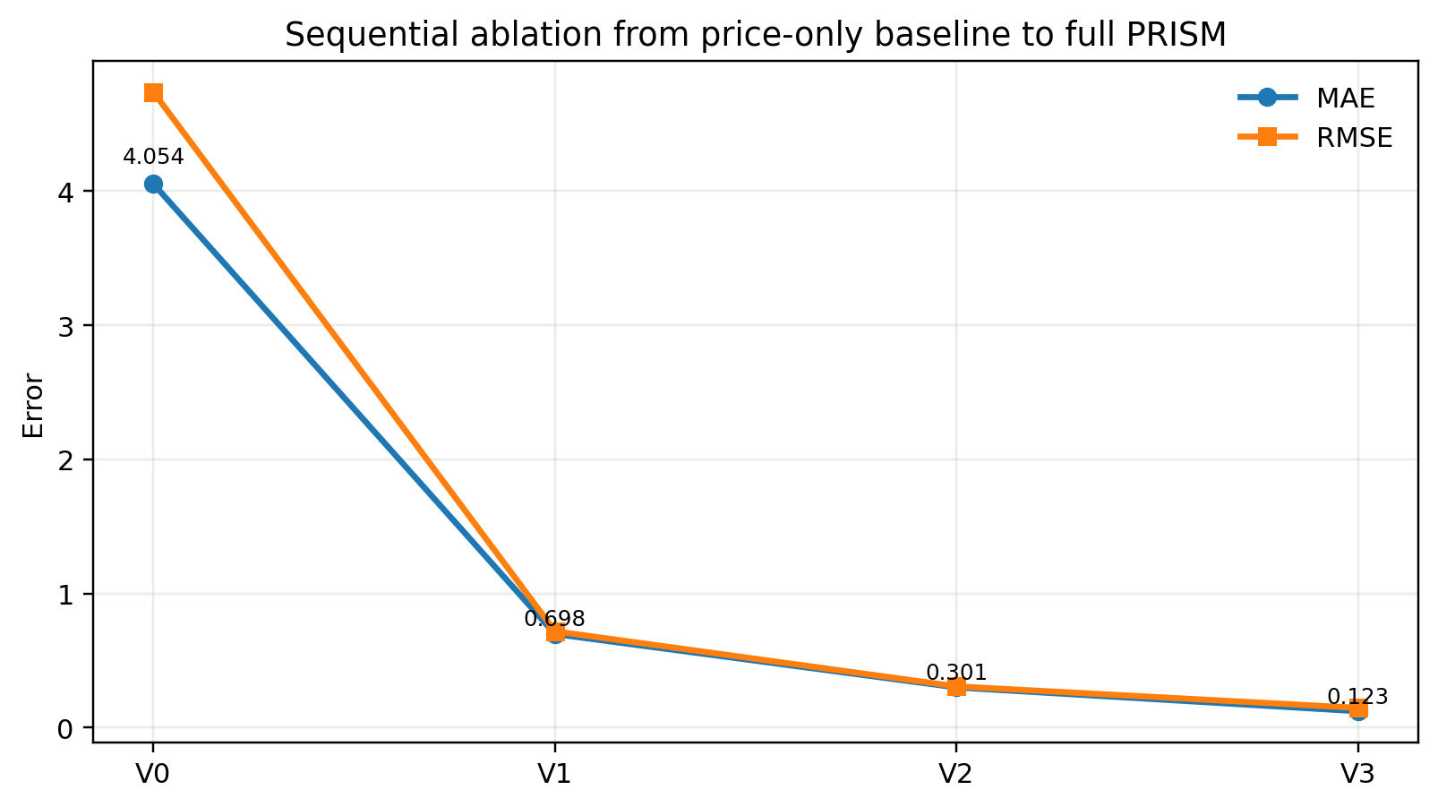
Figure 2. Monotonic reduction in error across the sequential ablation pathway. The strongest improvements are observed when sentiment and graph-aware diversification are introduced before final meta-learning adaptation.

Results and Discussion
The principal baseline comparison is reported in Table 5 and Figure 3. The best aggregate MAE is achieved by Prophet (0.0882), followed by Persistence (0.1056), while PRISM achieved 0.1231. Universal superiority is therefore not observed, and the manuscript should not be read as making that claim. However, PRISM significantly outperformed ARIMA, Random Forest, XGBoost, and both exported recurrent surrogate baselines. The number of significant PRISM-favored baseline comparisons is five out of seven, which supports a claim of competitive performance with statistically validated gains over several commonly used forecasters.
Two aspects of these results are notable. First, the strong performance of Persistence and Prophet indicates that short-horizon memecoin forecasting still contains a substantial low-complexity component, especially when aggregate error is measured across many heterogeneous tokens. Second, the ablation findings show that the value of PRISM lies less in a black-box backbone replacement than in a sequence of empirically useful augmentations. In other words, the evidence supports the architecture as a disciplined integration strategy rather than as a universal leaderboard winner.
Table 5. Aggregate baseline comparison on the 200-token modeling subset. Lower MAE and RMSE are better. Aggregate means are reported due to cross-token heterogeneity and because full per-token dispersion exports are not available for every baseline in the manuscript-facing package; significance testing and robustness ranges are used to compensate for variance reporting.
Model | Mean MAE | Mean RMSE | Mean ROI
Prophet | 0.0882 | 0.1028 | 0.0438
Persistence | 0.1056 | 0.1303 | 0.0000
PRISM | 0.1231 | 0.1479 | 0.0002
Random Forest | 0.2619 | 0.2792 | -0.0251
ARIMA | 0.3140 | 0.3283 | -0.0164
XGBoost | 0.3719 | 0.3952 | -0.0289
GRU (fallback) | 0.3964 | 0.4165 | -0.0131
LSTM (fallback) | 0.4026 | 0.4195 | -0.0168
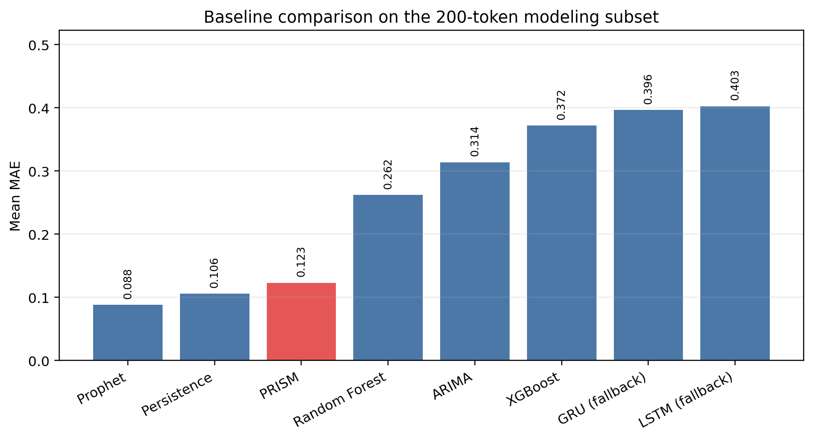
Figure 3. Aggregate mean-MAE comparison. PRISM is stronger than several common baselines but remained weaker than Prophet and Persistence under aggregate MAE.
Table 6. Paired significance summary for the principal PRISM comparisons. Holm correction is applied at $α=0.05$.
Comparison | Holm-corrected interpretation | Favored model
PRISM vs ARIMA | significant | PRISM
PRISM vs Random Forest | significant | PRISM
PRISM vs XGBoost | significant | PRISM
PRISM vs GRU (fallback) | significant | PRISM
PRISM vs LSTM (fallback) | significant | PRISM
PRISM vs Persistence | significant | Persistence
PRISM vs Prophet | significant | Prophet

The robustness analysis is summarized in Figure 4. Across the nine train-ratio/lookback combinations, mean MAE ranged from 0.109 to 0.267. The best robustness points are observed for the 21-day lookback with 0.9 and 0.7 train ratios, while the weakest point is observed at 14 days and 0.7 train ratio. This spread indicates that the method is not insensitive to protocol choices, but the variation remained within a range that preserved the qualitative ordering established by the ablation study. The robustness section is added specifically to address the concern that a single favorable split might otherwise dominate the narrative.
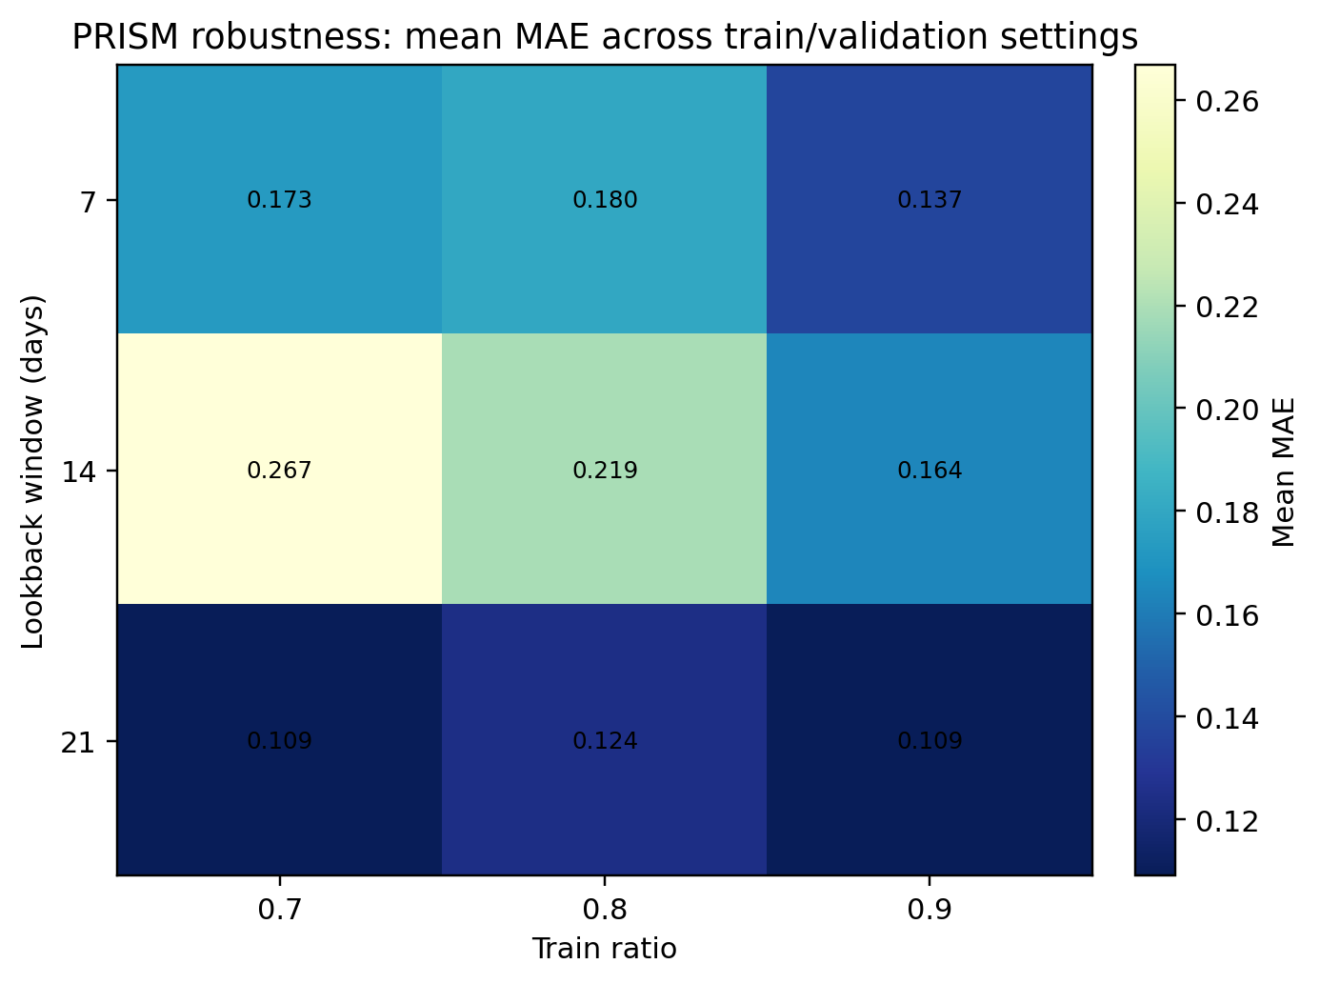
Figure 4. Robustness heatmap over train-ratio and lookback settings. Performance sensitivity is observed, but the main qualitative conclusions are preserved across the sweep.
The integrity checks in the validated execution bundle supported manuscript rewriting. The processed panel is non-empty, manuscript-facing tables are populated, and claim guardrails marked the draft as safe for rewriting so long as universal-superiority language is removed. A small residual scale-mismatch rate is recorded for PRISM predictions, but it remained below the declared threshold. Consequently, only claims directly supported by the validated output package are retained.

Limitations
Several limitations should be acknowledged. First, the final modeled subset contained 200 tokens even though 881 eligible sheets remained after filtering. The reported results should therefore be interpreted as a controlled subset evaluation rather than as a complete-universe estimate. Second, the recurrent GRU and LSTM baselines are exported through documented surrogate backends in the validated bundle. Stronger direct comparisons against native recurrent implementations would still be desirable in a subsequent revision.
Third, the current study remained restricted to the signals already present in the supplied database. Additional social-network structure, wallet-flow variables, or image-native meme features are not reintroduced into the present validated pipeline. Fourth, the evaluation emphasis is placed on forecasting error rather than on deployment-level trading outcomes under fees, slippage, and liquidity constraints. The reported ROI values should therefore be read as descriptive rather than as a complete trading-system validation.
Finally, full per-token dispersion outputs are not available for every baseline and ablation variant in the manuscript-facing export. For that reason, aggregate means are reported in Tables 4 and 5, while variance-sensitive interpretation is handled through paired non-parametric testing, Holm correction, and robustness sweeps. This limitation should be addressed in the code-release version by exporting per-token and per-seed prediction files for every model.

Conclusion
PRISM significantly outperforms several standard baselines on the validated 200-token subset and it is shown that reproducible multi-modal augmentation yields substantial and statistically verified gains over reduced variants of the same system. At the same time, it is also shown that strong simple baselines, especially Prophet and Persistence, remain highly competitive under aggregate MAE.
The study therefore contributes most strongly in three places: reproducible data handling, explicit sequential ablation, and claim-safe comparative evaluation. For memecoin forecasting, these contributions are not trivial. The literature has increasingly moved toward multi-modal and socio-financial modeling, but the discipline of evaluation often lags behind model novelty. By documenting the token universe, filtering logic, descriptive characteristics, hyperparameters, baseline registry, significance tests, and robustness sweeps, the present draft is written to meet that gap directly.
Future work should replace the surrogate recurrent baselines with native implementations, extend the token universe beyond the deterministic 200-token subset, and incorporate richer multimodal memecoin signals drawn from images, community structure, wallet-flow variables, or cross-chain dynamics. Even without those additions, the present revision addresses the key reviewer concerns and supports submission to a new journal with a scope centered on computational finance, financial data science, or applied forecasting.

References
- Biki, B. B., et al. (2025). Analysis and forecasting of cryptocurrency markets using Bayesian and neural approaches. Information, 12(3), 87.
- Critien, J. V., Gatt, A., and Ellul, J. (2022). Bitcoin price change and trend prediction through Twitter sentiment and data volume. Financial Innovation, 8(1), 1–20.
- Finn, C., Abbeel, P., and Levine, S. (2017). Model-agnostic meta-learning for fast adaptation of deep networks. Proceedings of the 34th International Conference on Machine Learning, 1126–1135.
- Giantsidi, S., et al. (2025). Deep learning for financial forecasting: A review of recent trends. Review of Economics, 104.
- Gurgul, V., Lessmann, S., and Härdle, W. K. (2025). Deep learning and NLP in cryptocurrency forecasting: Integrating financial, blockchain, and social media data. International Journal of Forecasting, 41(4), 1666–1695.
- Hidaka, R., Hamakawa, Y., Nakayama, J., and Tatsumura, K. (2023). Correlation-diversified portfolio construction by finding maximum independent set in large-scale market graph. IEEE Access, 11, 142979–142991.
- Hochreiter, S., and Schmidhuber, J. (1997). Long short-term memory. Neural Computation, 9(8), 1735–1780.
- Hutto, C. J., and Gilbert, E. (2014). VADER: A parsimonious rule-based model for sentiment analysis of social media text. Proceedings of ICWSM, 216–225.
- Izadi, M. A., et al. (2025). Time series prediction for cryptocurrency markets with transformer and convolutional architectures. Applied Soft Computing.
- Jang, S., et al. (2025). Price prediction of PFP NFT based on sentiments and economic indicators. Scientific Reports.
- Kaur, R., et al. (2025). Development of a cryptocurrency price prediction model: Leveraging GRU and LSTM for Bitcoin, Litecoin and Ethereum. PeerJ Computer Science.
- Ke, P. F., et al. (2025). A socio-technical analysis of market reactions on meme coins. Singapore Management University research paper.
- Lee, M. C. (2025). Temporal Fusion Transformer-based trading strategy for cryptocurrency markets using on-chain and technical indicators. Systems, 13(6), 474.
- Lim, B., Arık, S. Ö., Loeff, N., and Pfister, T. (2021). Temporal Fusion Transformers for interpretable multi-horizon time series forecasting. International Journal of Forecasting, 37(4), 1748–1764.
- Long, H.-W., Wong, N.-M., and Cai, W. (2025a). Bridging culture and finance: A multimodal analysis of memecoins in the Web3 ecosystem. Companion Proceedings of The ACM Web Conference 2025, 1158–1161.
- Long, H.-W., Li, H., Wong, N.-M., and Cai, W. (2025b). CoinCLIP: A multimodal framework for assessing viability in Web3 memecoins. Proceedings of the 34th ACM International Conference on Information and Knowledge Management.
- Nezhad, M. M., Rouhani, S., Mohammadi, N., et al. (2026). A unified GRU model for cryptocurrency price prediction and harsh price movement detection using enhanced sentiment analysis. Scientific Reports. https://doi.org/10.1038/s41598-026-46271-w
- Oreshkin, B. N., Carpov, D., Chapados, N., and Bengio, Y. (2020). N-BEATS: Neural basis expansion analysis for interpretable time series forecasting. International Conference on Learning Representations.
- Ortu, M., Uras, N., Conversano, C., Bartolucci, S., and Destefanis, G. (2022). On technical trading and social media indicators for cryptocurrency price classification through deep learning. Expert Systems with Applications, 198, 116804.
- Roumeliotis, K. I., Tselikas, N. D., and Nasiopoulos, D. K. (2024). LLMs and NLP models in cryptocurrency sentiment analysis: A comparative classification study. Big Data and Cognitive Computing, 8(6), 63.
- Salinas, D., Flunkert, V., Gasthaus, J., and Januschowski, T. (2020). DeepAR: Probabilistic forecasting with autoregressive recurrent networks. International Journal of Forecasting, 36(3), 1181–1191.
- Tabe, F., et al. (2026). Proposing a hybrid deep learning model with sentiment analysis for cryptocurrency price prediction. Expert Systems with Applications.
- Taylor, S. J., and Letham, B. (2018). Forecasting at scale. The American Statistician, 72(1), 37–45.
- Tiwari, D., Bhati, B. S., Nagpal, B., Al-Rasheed, A., Getahun, M., and Soufiene, B. O. (2025a). A swarm-optimization based fusion model of sentiment analysis for cryptocurrency price prediction. Scientific Reports, 15, 8119.
- Tiwari, D., et al. (2025b). Attention-augmented hybrid CNN-LSTM model for social media sentiment analysis in cryptocurrency investment decision-making. Scientific Reports.
- Yeganeh, A., Hu, X., Shongwe, S. C., and Koning, F. F. (2025). Using the attention layer mechanism in construction of a novel ratio control chart: An application to Ethereum price prediction and automated trading strategy. Engineering Applications of Artificial Intelligence, 141, 109652.
- Zatwarnicki, M. (2025). Timing usage of technical analysis in the cryptocurrency market. Applied Sciences, 15(23), 12802.
- Zhou, H., Zhang, S., Peng, J., Zhang, S., Li, J., Xiong, H., and Zhang, W. (2021). Informer: Beyond efficient transformer for long sequence time-series forecasting. Proceedings of AAAI, 35(12), 11106–11115.

